Please attach this file when sending your recordings by Wetransfert to the following address
concoursmanchicourt@gmail.com
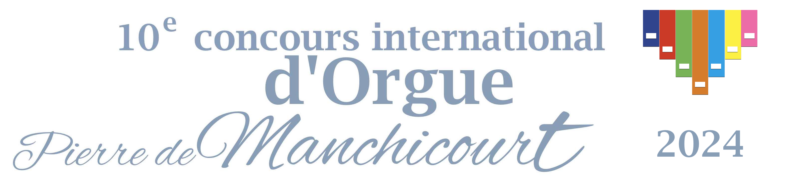
Application form for the 10th Edition of the international contest
« Pierre de Manchicourt »

Agreement of the contest rules

[…] I have taken knowledge of all the contest rules and I accept their conditions.

Surname : …………………………………………….

Name : ………………………………………………

Birth date : ………………………………………..

Birth place : ……………………………………..

Nationality : ……………………………………..

Adress : …………………………………………

Postal code : …………………………………….

Town : …………………………………………….

Country : ……………………………………………

Phone number : …………………………………….

E-mail : ………………………………………….

You should use the same Email as the email used to send the files via http://wetransfer.com

Chosen organ

[…] 1. Saint-Omer

[…] 2. Béthune

You must select one or two organs.

